Submission code: (to be given by the conference organizer)

**Instructions for the Preparation of Paper**

First Name Family Name a, Adam Carlingb*, Thomas Collinc

a Chulalongkorn University, Bangkok, Thailand. Email address: author@abc.edu.co

b Department of Logistics Management, ABC University, City, Country; * Corresponding author, Email address: author@abc.edu.co

c Department of XYZ, DEF University, City, Country. Email address: author@abc.edu.co

# Abstract (font size 12 points)

Authors preparing extended abstract/full paper for IWT 2025 should format the paper title in a 12-point font and the main text in an 11-point font. Submissions must include the research background, methodology, and significance, and should be between 5 to 8 pages in English. Papers must be submitted via email to **iwt2025@chula.ac.th**. All submissions will undergo peer review, and only accepted papers will be presented at the conference. Best Paper Awards will be given to selected presentations with full-paper submissions, provided the participant is the first author.

**Keywords:** (limited to five keywords only)

# Introduction (font size 12 points)

Authors may determine the sessions according to their paper contents.

**Table 1.** Example of tables

|  |  |  |  |
| --- | --- | --- | --- |
|  |  |  |  |
|  |  |  |  |
|  |  |  |  |

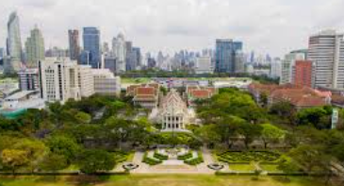

**Figure 1.** Example of Literature review

**Acknowledgements**

**References** (See examples of reference style below.)

Chen, J.K., Kim, Y.S., Lim, S. and Patton, J., 2018. River-Sea Combined Transport. Journal of International Maritime Transport, 24(1), 123-130.

Smith, J. and Gratton, P., 2016. Dynamics of Logistics in the Globalized Economy. Published city: Publishing Company.

(* In case of website citation, please indicate accessed date after the website.)